**Exercises 1**

1. Create a constant called age1 and set it equal to 42. Create another constant

called age2 and set it equal to 21. Check that the type for both constants has

been inferred correctly as int by hovering your mouse pointer over the variable

names in VS Code.

2. Create a constant called averageAge and set it equal to the average of age1 and

age2 using the operation (age1 + age2) / 2. Hover your mouse pointer over

averageAge to check the type.

Then check the result of averageAge. Why is it a double if the components are all int?

**Because there is a divison process, the result is expected to be double.**

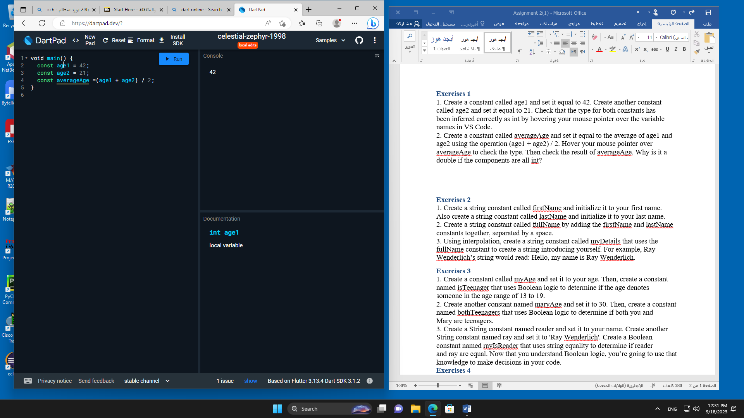

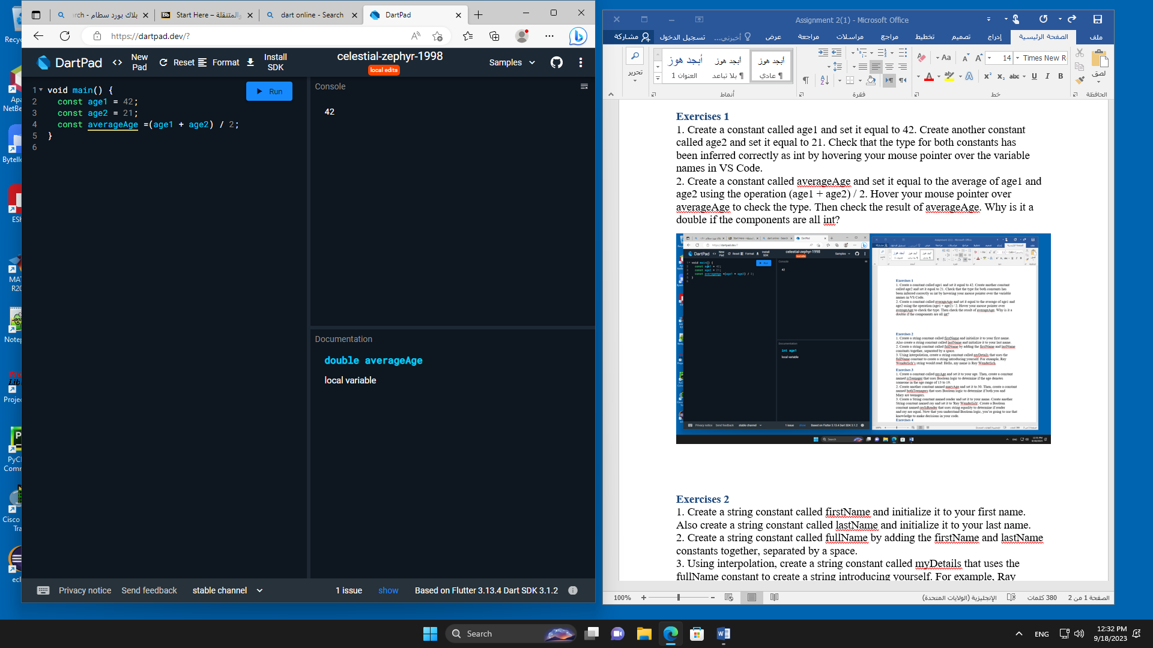

**Exercises 2**

1. Create a string constant called firstName and initialize it to your first name.

Also create a string constant called lastName and initialize it to your last name.

2. Create a string constant called fullName by adding the firstName and lastName

constants together, separated by a space.

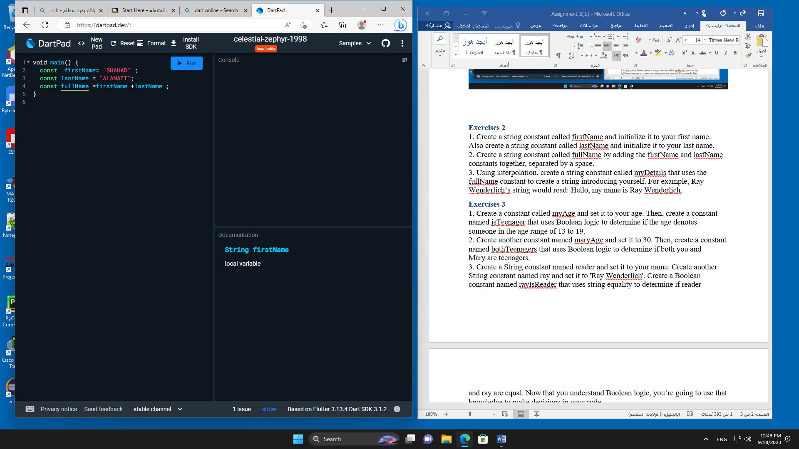

3. Using interpolation, create a string constant called myDetails that uses the

fullName constant to create a string introducing yourself. For example, Ray

Wenderlich’s string would read: Hello, my name is Ray Wenderlich.

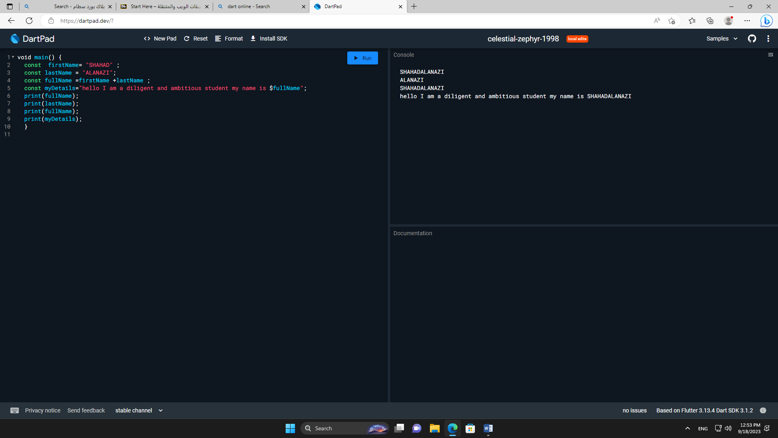

**Exercises 3**

1. Create a constant called myAge and set it to your age. Then, create a constant

named isTeenager that uses Boolean logic to determine if the age denotes

someone in the age range of 13 to 19.

2. Create another constant named maryAge and set it to 30. Then, create a constant

named bothTeenagers that uses Boolean logic to determine if both you and

Mary are teenagers.

3. Create a String constant named reader and set it to your name. Create another

String constant named ray and set it to 'Ray Wenderlich'. Create a Boolean

constant named rayIsReader that uses string equality to determine if reader

and ray are equal. Now that you understand Boolean logic, you’re going to use that knowledge to make decisions in your code.

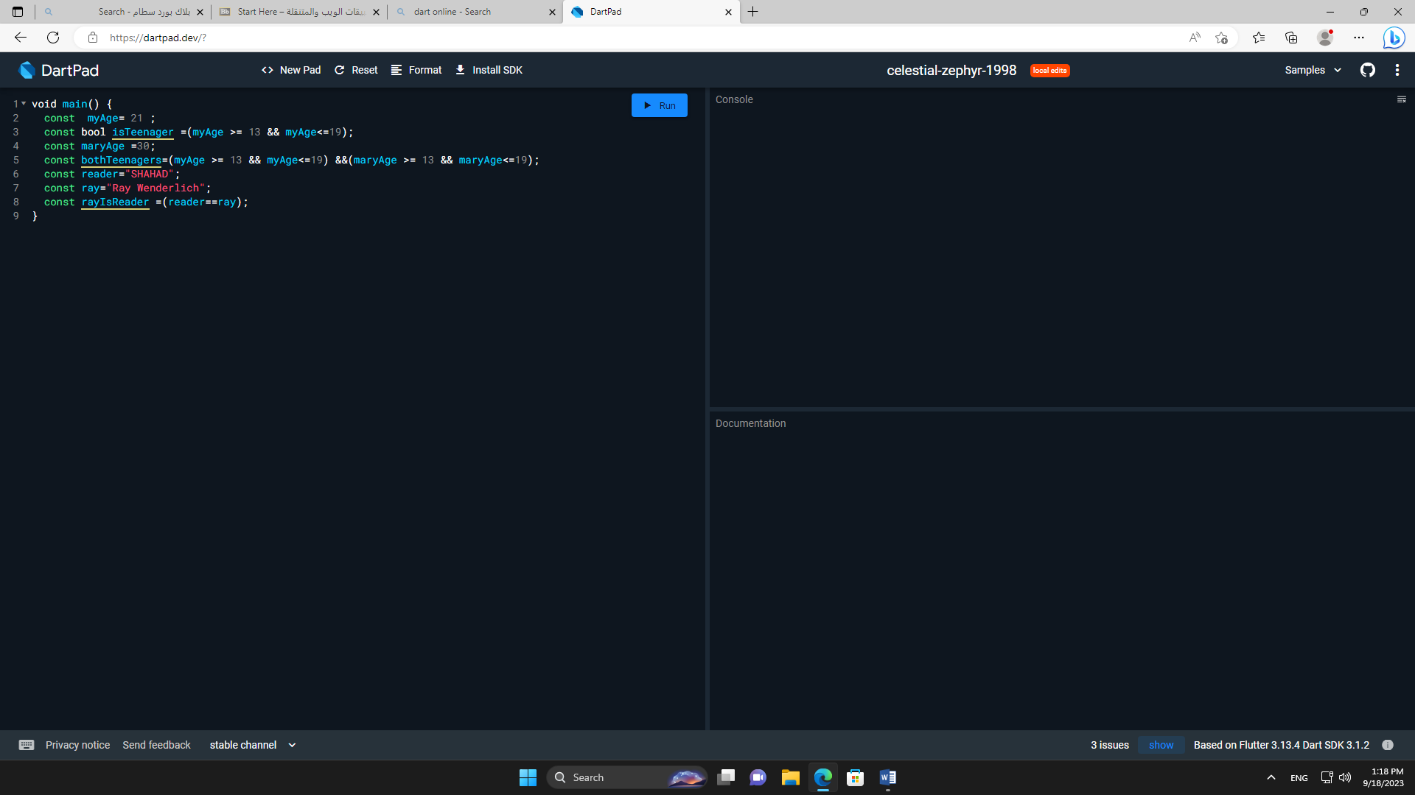

**Exercises 4**

1. Create a constant named myAge and initialize it with your age. Write an if

statement to print out “Teenager” if your age is between 13 and 19, and “Not a

teenager” if your age is not between 13 and 19.

2. Use a ternary conditional operator to replace the else-if statement that you

used above. Set the result to a variable named answer.

